Melting Point Determination

**Reference:** Handout; Chemistry Lessons: melting points of solids, melting point determination; Green Lessons: solvent-less reactions

**Purpose:** To determine unknown crystalline compounds and indicate purity through the use of specific melting points

**Balanced Chemical Equation:**

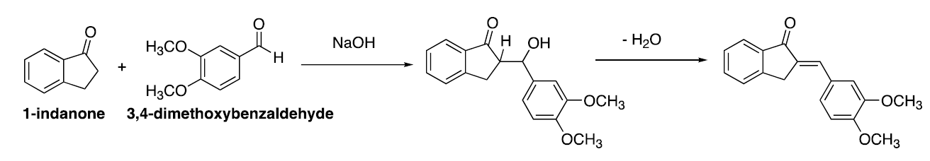

Solvent-less Aldol Reaction

**Table of Reagents:**

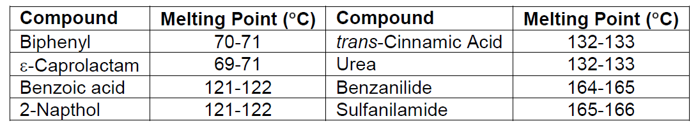

**Safety:** Avoid contact with your eyes. Do not ingest or inhale the reagents. Place any waste in their appropriate containers.

|  |  |
| --- | --- |
| **Experimental Procedures** | **Data & Observations** |
| **1.** Obtain the unknown sample, and record the name and number of the sample | *Unknown Sample:* #8 |
| **2.** Take your solid sample and push the open-end of the melting point capillary tube into the sample. Tap the capillary tube until 1-2 mm of the sample is packed at the bottom. Repeat for the 2nd tube. | *Sample:* White in color, fine in texture  *Tube 1:* 2 mm of sample  *Tube 2:* 2 mm of sample |
| **3.** Acquire tube 1, this will be used to determine the approximate melting point range. Start with a broad temperature range, and make sure the rate of heating is 5 °C/min. | *Machine:* OptiMelt  *Starting Temperature:* 50 °C  *Rate of Heating:* 5 °C/min  *Unknown Sample Melted:* 135 °C  *Observations:* Turned brown then liquid |
| **4.** Narrow down the identity of the unknown sample to two possibilities (use the melting point ranges). | *Predicted Compound:* trans-Cinnamic Acid |
| **5.** Acquire your predicted compound and mix with equal mass (~50 mg) with your unknown sample in tube 2. Begin with the starting temperature roughly 15 °C below the predicted melting point. Make sure the rate of heating is 1-2 °C/min. | *Machine:* OptiMelt  *Starting Temperature: 10*0 °C  *Rate of Heating:* 5 °C/min  *Unknown mixed with Known Melted:* 135 °C  *Observations:* Turned brown then liquid |
| **6.** Confirm the identity of your unknown sample. If the mixed sample melted before the unknown sample melting point, then the unknown sample must be the other prediction. Otherwise, you correctly predicted the known sample! | *Chemical Identity of Unknown:* trans-Cinnamic Acid |

**Post-lab Questions:**

**1.** We were originally given unknown #8 and we determined that the identity of our unknown was trans-Cinnamic Acid.After melting the sample from our first tube, we tested that the unknown sample had a melting point of 135 °C, which falls within the ranges for the known samples trans-Cinnamic Acid and Urea. We chose trans-Cinnamic Acid as our predicted compound, since its texture resembles that of our unknown. We repeated the experiment, but this time we mixed our predicted known sample with our unknown. The experiment resulted in a success as our newly mixed sample had the same melting point.

**2.** The melting point range of an impure compound will be lower and broader than the melting point range for the pure compound.

**3.** Melting Point Depression is responsible for the difference in melting points as pure compounds would have the same melting points, while impure compounds would melt at a lower temperature.

**4.** It is important to control the rate of heating close to the melting point, since the melting point range of compounds is very small and heating the apparatus too fast will result in an inaccurate data collection.

**5.** To start, Johnny should take the unknown vials and label them ‘A’ and ‘B’. Next, he should take the pure, known sample of ‘A’ and mix it with the unknown, labeled sample of ‘A’ in a capillary tube. Johnny should then heat up the mixture of the known and unknown samples of ‘A’, starting with temperature at 80 °C and slowly increasing the heat by 1-2 °C/min. If the sample melts before the expected melting point range of 102-104 °C (melting point depression occurred), then the labels should be switched. However, if the sample melts within the range, then Johnny predicted the right labels.